CO2 - AT1 - Database Design and Connectivity
Vedvyass M – 192324267

1. Employee and Department Database Design

Objective :

To design an SQLite database with Department and Employee tables using primary and foreign keys, insert sample data, and retrieve employee names along with their department names using an SQL JOIN query.

Procedure :

- Import the sqlite3 module.
- Connect to an SQLite database named employee.db.
- Create the Department table with DepartmentID as the Primary Key.
- Create the Employee table with EmployeeID as the Primary Key and DepartmentID as the Foreign Key.
- Insert sample records into both tables.
- Execute an SQL JOIN query to display employee names and their department names.
- Display the results and close the database connection.

Code :

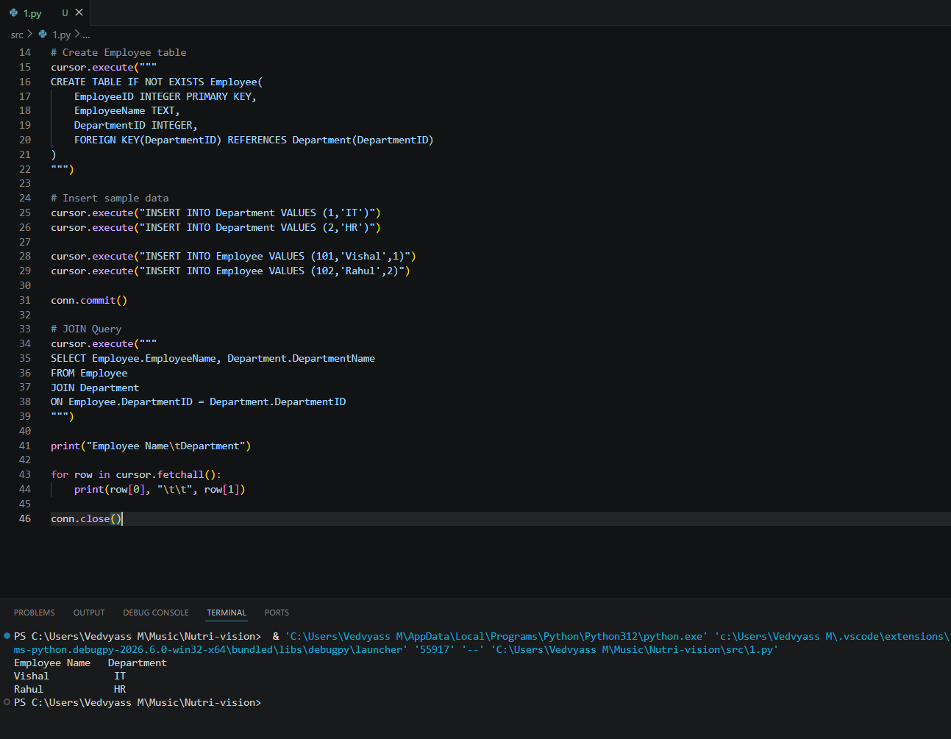

2. Hospital Patient Database

Objective :

To design a Hospital Patient database using SQLite, perform CRUD operations (Create, Read, Update, Delete), and display the remaining patient records after deleting a discharged patient.

Procedure :

- Import the sqlite3 module.
- Connect to hospital.db.
- Create the Patient table.
- Insert sample patient records.
- Update the contact number of a patient.
- Delete the discharged patient's record.
- Display the remaining patient records.
- Close the database connection.

CODE :

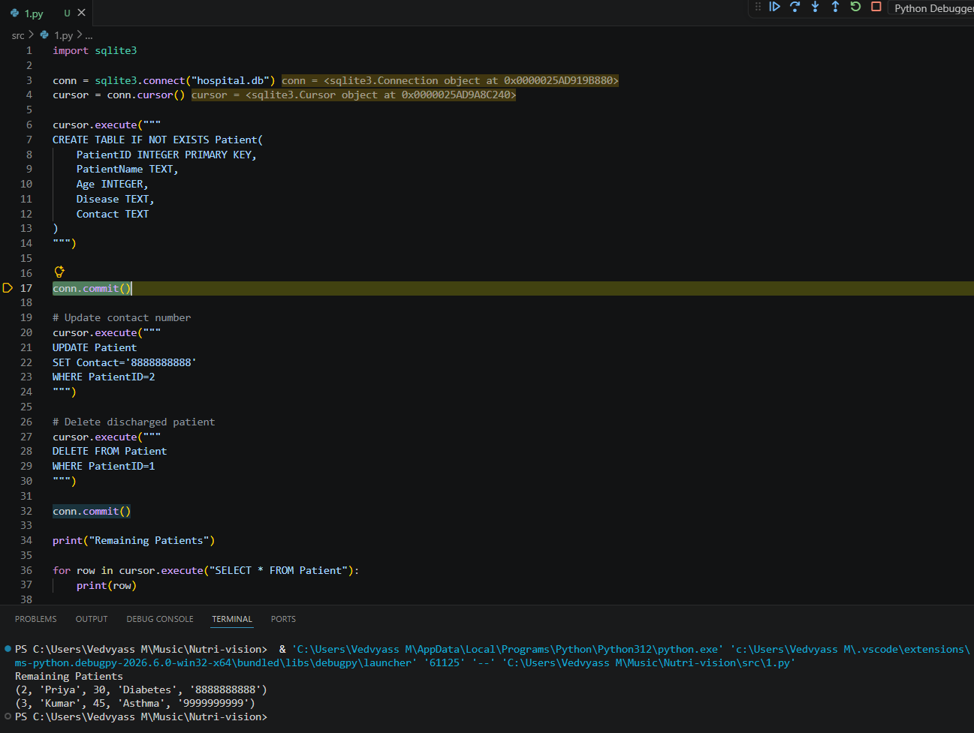

3. Online Course Registration System

Objective :
To design an SQLite database with Student and Course_Registration tables using primary and foreign keys, insert sample records, and retrieve student names with their registered courses using an SQL JOIN query.

Procedure :
- Import the sqlite3 module.
- Connect to course.db.
- Create the Student table.
- Create the Course_Registration table with a foreign key.
- Insert sample student and course registration records.
- Execute an SQL JOIN query.
- Display student names with their registered courses.
- Close the database connection.

Code :
